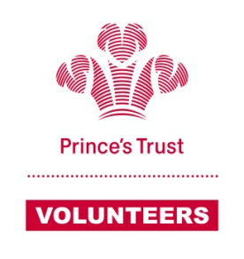
Mentoring Agreement –
THE ‘RULES’ OF MENTORING
Young Person  I agree;  - to work with my mentor to identify what I would like to achieve in terms of education, employment, self-employment or training  - to work to achieve my goals, with support from my mentor  - to respond quickly to contact from my mentor  - to always turn up for meetings on time  - if I have to cancel a meeting, I will give my mentor as much notice as I can  I also understand that my mentor is a volunteer and is not being paid to support me. It is important, therefore, that I treat them with respect at all times. | Mentor  I agree;  - to work with the young person to identify goals and actions needed to support their training and personal development  - to meet my young person face-to-face on a regular basis appropriate to their needs. At least once a month for up to the first year of our support  - to keep in contact with the young person, even if there are occasions when they don’t respond to my contacting them  - to be supportive of my young person and agree clear and realistic goals  - to keep my Prince’s Trust contact updated through regular reports

We both understand:
- There should be no home visits under any circumstances
- Meetings should always take place in a public place, suitable for serious discussion.
- There should be no car lifts for either party under any circumstances
- Absolutely no money or commercial interest should be involved, this includes lending or borrowing
- Things discussed during meetings are confidential. However the mentor will keep The Prince’s Trust in touch with how the relationship is developing and what is being discussed. If the mentor has any concerns which may impact a young person’s or another’s’ wellbeing or safety, they must share this with The Trust
- That we should not bring friends or family to the meetings unless previously agreed. The mentoring relationship is between the young person and the mentor only
- This is a friendly, but professional relationship, therefore social activities outside the mentor relationship are not deemed appropriate

 | Signature | Date
Mentor
Young Person

