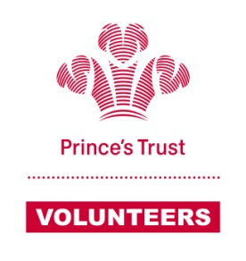

Mentor meeting report

Please briefly and factually complete this report after each mentoring session and return it to <insert name> within 48-hours. All reports will be read, responded to and kept on file for use in reviews.

Mentor name
Mentee name(s)
Business Name
Business Status | Full Trading | Part Trading | Business On Hold |  | Ceased
Meeting Date |  | Meeting Location
Meeting Duration |  | Next Meeting Date
Additional time | Additional time working with young person since last meeting
Financial Information |  | Comment (e.g. details of short term financial commitments; explanations for large or one off transactions)
Opening Balance
Cash In
Cash Out
Closing Balance

Progress: What progress has been achieved by the mentee and / or you on previously agreed actions?

Outline topics covered at this meeting (e.g. progress against business plans, opportunities, threats, areas requiring further support; contact detail changes; and guidance given)
Actions: List any actions agreed from this meeting and who will carry them out

Do you have any concerns (E.g. wellbeing or safeguarding) or further comments? Anything you wish to discuss with Trust staff?

Text Survey complete? |  | This will be sent to all young people three months, six months and twelve months after they complete the programme. This survey will ask about what they are doing now and what they thought of the programme. Please encourage the mentee to complete this

Thank you for completing the mentor meeting report. The is essential to ensure we can better support your mentoring relationship. Please share a copy of this report with the young person.

 | Signature | Date
Mentor
Young Person

