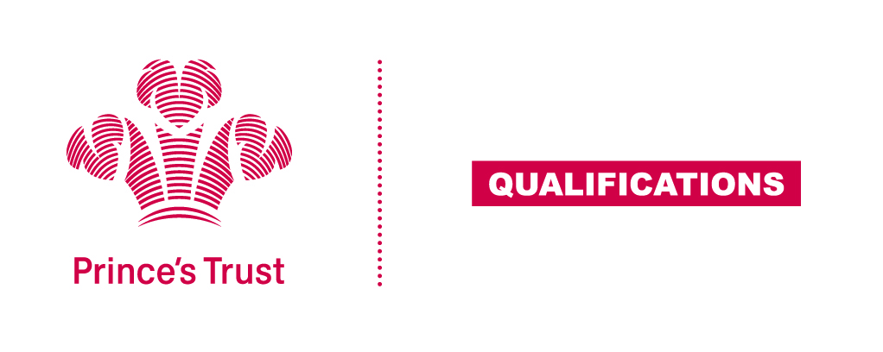
Tracking sheet – Teamwork Skills
The aim of this unit is to help the learner develop team working skills, by understanding the values, roles and procedures of teams and being able to work with others towards achieving shared objectives.
The team activity should be collaborative and purposeful and give each learner the opportunity to meet all the criteria. This unit lends itself particularly well to being integrated with other aspects of the learner’s wider programme.
SCQF Level 5
Learner name Centre name
To do this you must | Page number | Assessment date
- Understand the importance of teamwork
  - Describe the advantages of working as a team
  - Describe the problems that could occur when working as a team
1.3 Explain why teamwork is essential in two situations
- Understand roles and relationships within a team
  - Outline characteristics of an effective team
2.2 Describe different roles for team members whilst completing an activity
  - Explain the need for different roles within a team
2.4 Describe different ways of making decisions in a team
2.5 Describe different ways to resolve conflict within a team
- Be able to take part in team activities
  - Outline the objectives of different team activities
3.2 Participate in team activities
3.3 Explain your role within the team activities
3.4 Give constructive feedback to different team members
3.5 Obtain constructive feedback from different team members
- Be able to evaluate own performance
  - Explain how the team worked well
4.2 Describe skills you have developed while working as a team
  - Describe ways to improve own team working skills
Assessor feedback
Declaration I confirm that the details above are correct, that the evidence submitted is the learner’s own work and that the learner meets all the requirements for the unit:
Learner Name Assessor Name

Learner Signature Assessor Signature

Date Date

