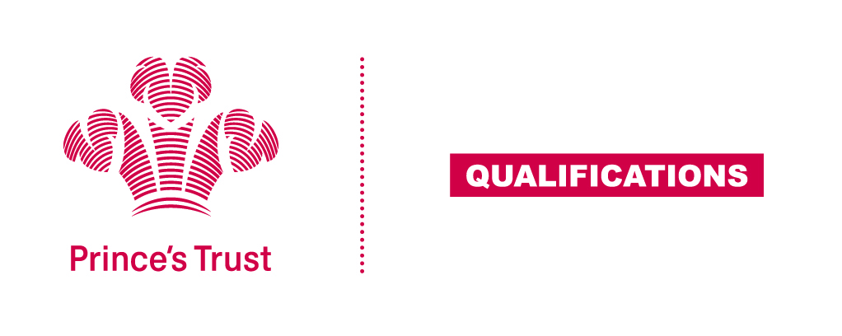
Tracking sheet – Digital Skills
The aim of this unit is to ensure learners are confident in using their digital skills to find, present and share information, are aware of the wider uses digital skills have within a workplace and understand some of the implications to using technology as a form of communication, both positive and negative.
SCQF Level 5
Learner name Centre name
To do this you must | Page number | Assessment date
- Understand e-safety
1.1 Explain what is meant by "e-safety"
1.2 Describe the consequences of positive and negative online behaviour
1.3 Explain what features make a password secure
- Understand uses of digital skills and tools
2.1 Describe tasks that require digital skills
2.2 Explain the advantages and disadvantages of different digital communication tools
- Be able to use digital tools to find and present information
3.1 Use the internet to find information on a subject from different sources
3.2 Present information using different digital tools
- Be able to review own digital skills and identify areas for development
4.1 Give examples of own digital skills that need to be developed
4.2 Describe ways these digital skills can be developed
Assessor feedback
Declaration I confirm that the details above are correct, that the evidence submitted is the learner’s own work and that the learner meets all the requirements for the unit:
Learner Name Assessor Name

Learner Signature Assessor Signature

Date Date

