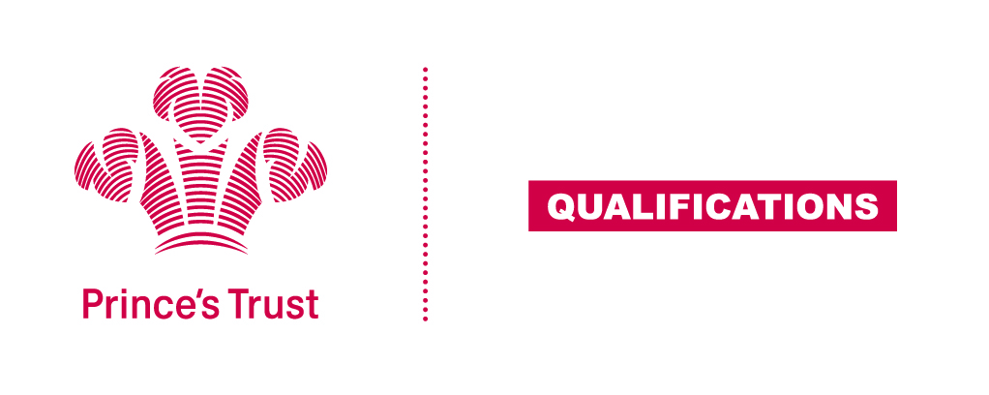
Tracking sheet – Interpersonal and Self-management Skills
The aim of this unit is for learners to develop an understanding of interpersonal and self-management skills and be able to recognise these skills in themselves and others. Learners will consider the body language used by themselves and others, time management skills and passive, assertive and aggressive behaviour and how to recognise and manage stress
These are important employability skills and learners who are able to acknowledge and demonstrate these skills are in a more favourable position when it comes to interviews and on the job performance.
SCQF Level 4
Learner name Centre name
To do this you must | Page number | Assessment date
- Be able to recognise a range of interpersonal skills
  - Give examples of positive body language
1.2. Give examples of negative body language
1.3 Give examples of aggressive, assertive and passive behaviour
- Understand the importance of self-management
2.1 State why time management is important
2.2 Give examples of how own time can be managed better
2.3 Identify signs of stress
2.4 Give examples of how to manage own stress appropriately
- Be able to demonstrate appropriate interpersonal skills
3.1 Use appropriate body language when responding to others
3.2 Communicate appropriately with others
- Be able to review own interpersonal and self-management skills
4.1 Identify own strengths in relation to interpersonal or self-management skills
4.2 Give examples of how to improve own interpersonal or self- management skills
Assessor feedback
Declaration I confirm that the details above are correct, that the evidence submitted is the learner’s own work and that the learner meets all the requirements for the unit:
Learner Name Assessor Name

Learner Signature Assessor Signature

Date Date

