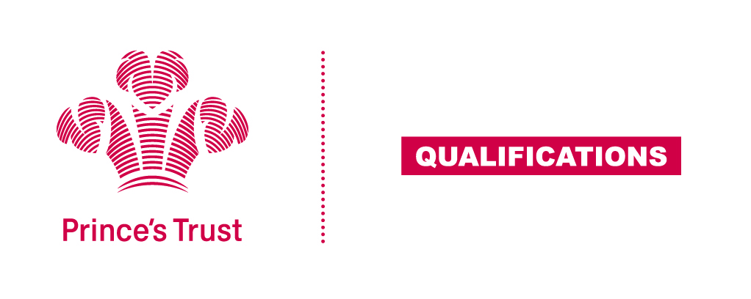
Tracking sheet – Digital Skills
The aim of this unit is to ensure learners are confident in using their digital skills to find, present and share information, are aware of the wider uses digital skills have within a workplace and understand some of the implications to using technology as a form of communication, both positive and negative.
SCQF Level 4
Learner name Centre name
To do this you must | Page number | Assessment date
- Understand e-safety
1.1 State what is meant by "e-safety"
1.2 Give examples of positive and negative online behaviours
1.3 Give examples of features that make a password secure
- Understand uses of digital skills and tools
2.1 Give examples of tasks which require digital skills
2.2 State the advantages and disadvantages of different digital communication tools
- Be able to use digital tools to find and present information
3.1 Use the internet to find information on a subject from different sources
3.2 Present information using digital tools
- Be able to review own digital skills and identify areas for development
4.1 Give examples of own digital skills that need to be developed
4.2 Identify ways to develop these digital skills
Assessor feedback
Declaration I confirm that the details above are correct, that the evidence submitted is the learner’s own work and that the learner meets all the requirements for the unit:
Learner Name Assessor Name

Learner Signature Assessor Signature

Date Date

