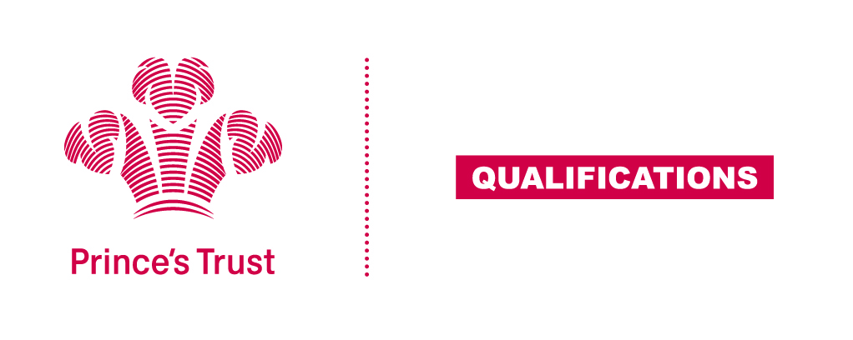
Tracking sheet – Teamwork Skills
The aim of this unit is to help the learner develop team working skills, by understanding the values, roles and procedures of teams and being able to work with others towards achieving shared objectives.
The team activity should be collaborative and purposeful and give each learner the opportunity to meet all the criteria. This unit lends itself particularly well to being integrated with other aspects of the learner’s wider programme.
SCQF Level 3
Learner name Centre name
To do this you must | Page number | Assessment date
- Understand the importance of teamwork
  - Identify an advantage of working in a team
  - Identify a problem that could occur when working in a team
- Understand roles and relationships within a team
2.1 Identify different roles for team members whilst completing an activity
- Be able to take part in team activities
  - Identify an objective of a team activity
3.2 Participate in team activities
- Be able to evaluate own performance
  - Identify what went well when working as part of a team
  - Identify a task that could have been improved
Assessor feedback
Declaration I confirm that the details above are correct, that the evidence submitted is the learner’s own work and that the learner meets all the requirements for the unit:
Learner Name Assessor Name

Learner Signature Assessor Signature

Date Date

