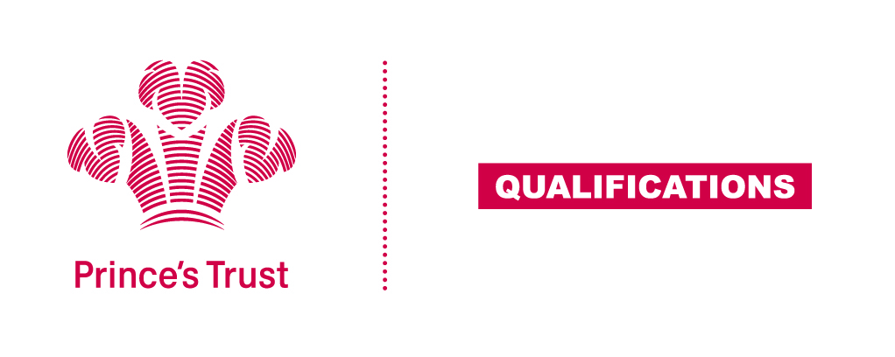
Tracking sheet – Customer Service
The aim of this unit is to develop learners’ understanding of the benefits of good customer service and how an organisation can provide effective levels of customer service through their procedures and good practice standards. Learners are required to each interact with customers and demonstrate good customer service standards in a real situation.
Level 2
Learner name Centre name
To do this you must | Page number | Assessment date
- Understand features of good customer service
1.1 Describe examples of good customer service
  - Describe examples of poor customer service
  - Explain how customer service can influence customers
1.4 Describe how organisations can provide good customer service
- Understand customer needs and how own organisation tries to meet them
2.1 Describe the products or services own organisation provides to customers
2.2 Describe how own organisation provides products/services in ways that meet customer needs
2.3 Describe different ways of gathering customer feedback
2.4 Explain the importance of gathering customer feedback
- Understand own organisation’s customer service procedures and good practice standards
3.1 Describe own role and responsibilities in relation to customer service
3.2 Describe own organisation’s procedures for resolving customer complaints
- Be able to provide good customer service
4.1 Provide good customer service
- Be able to review customer service in own organisation
5.1 Describe ways to improve customer service in own organisation
Assessor feedback
Declaration I confirm that the details above are correct, that the evidence submitted is the learner’s own work and that the learner meets all the requirements for the unit:
Learner Name Assessor Name

Learner Signature Assessor Signature

Date Date

