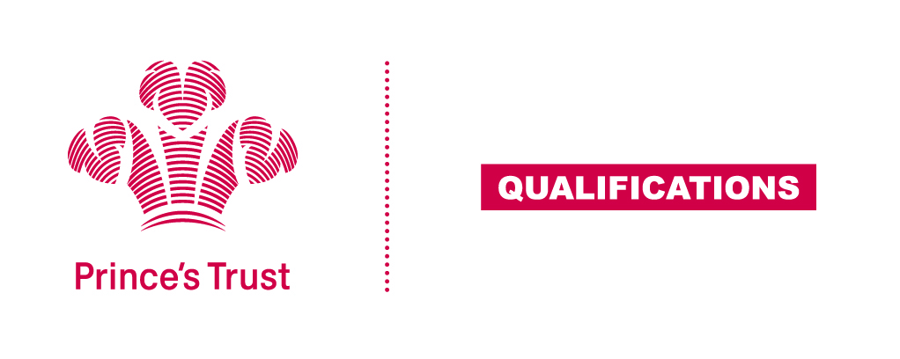
Tracking sheet – Community Project
The aim of this unit is for the learner to plan, complete and review a project in the wider community. As part of the planning the learners should have some involvement in selecting the project undertaken. The community project can be completed by an individual but is more likely to be undertaken by a group of learners and as such they will look at how the skills within the group can be used to complete the project by dividing up the different roles and responsibilities.
The length and scope of the project will depend on the time and resources available however, it should reflect the 60 TQT assigned to the unit. The tutor/supervisor will need to ensure all aspects of the project are safe and legal.
Level 2
Learner name Centre name
To do this you must | Page number | Assessment date
- Understand the needs of their wider community and how they can be met
1.1 Describe the needs of the wider community
  - Assess the advantages and disadvantages of two potential community projects
  - Explain why the community project was chosen
1.4 Explain how the project is going to meet the needs of the wider community
- Be able to plan a suitable community project
  - Produce a detailed plan for the activities stating who will complete each task and when
  - List the resources needed for the community project
  - Calculate costs or Gift in Kind savings associated with the community project
2.4 Explain with reasons any external help required
- Be able to carry out a community project
  - Complete a risk assessment for tasks you are responsible for
  - Complete task/s for which you are responsible
  - Contribute to completion of group task/s
3.4 Review the project’s progress at a mid-way point
- Be able to review the community project
  - Evaluate the community project taking into account the tasks that were completed well and making suggestions for tasks that could have been improved.
  - Explain what skills you have developed by planning and completing the community project
- Understand the wider community
5.1 Explain what you have learned about the wider community while completing the project
Assessor feedback
Declaration I confirm that the details above are correct, that the evidence submitted is the learner’s own work and that the learner meets all the requirements for the unit:
Learner Name Assessor Name

Learner Signature Assessor Signature

Date Date

