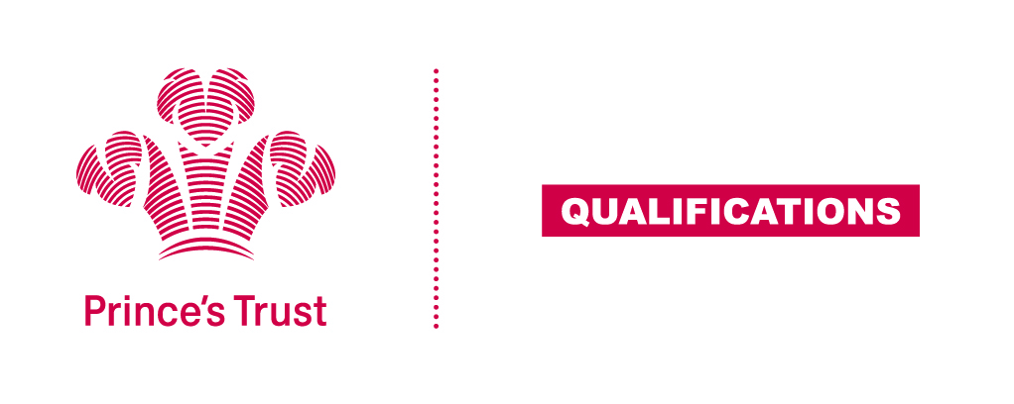
Tracking sheet – Teamwork Skills
The aim of this unit is to help the learner develop team working skills, by understanding the values, roles and procedures of teams and being able to work with others towards achieving shared objectives.
The team activity should be collaborative and purposeful and give each learner the opportunity to meet all the criteria. This unit lends itself particularly well to being integrated with other aspects of the learner’s wider programme.
Level 1
Learner name Centre name
To do this you must | Page number | Assessment date
- Understand the importance of teamwork
  - Identify the advantages of working as a team
1.2 Give examples of the problems that could occur when working as a team
1.3 Identify two situations where teamwork is essential
- Understand roles and relationships within a team
2.1 Identify different roles for team members whilst completing an activity
  - Describe the need for different roles within a team
  - Identify different ways of making decisions in a team
  - Give examples of ways to resolve conflict within a team
- Be able to take part in team activities
3.1 Identify objectives for a team activity
  - Participate in team activities
  - Identify your role within the team activities
3.4 Give constructive feedback to a team member
3.5 Obtain constructive feedback from a team member
- Be able to evaluate own performance
  - Give examples of how the team worked well
4.2 Give examples of skills you have developed while working as a team
  - State ways to improve own team working skills
Assessor feedback
Declaration I confirm that the details above are correct, that the evidence submitted is the learner’s own work and that the learner meets all the requirements for the unit:
Learner Name Assessor Name

Learner Signature Assessor Signature

Date Date

