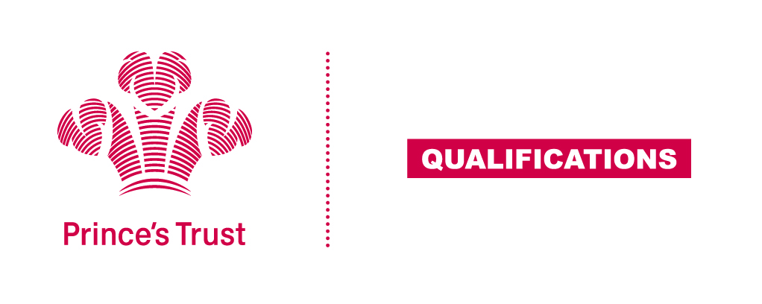
Tracking sheet – Customer Service
The aim of this unit is to develop learners’ understanding of the benefits of good customer service and how an organisation can provide effective levels of customer service through their procedures and good practice standards. Learners are required to each interact with customers and demonstrate good customer service standards in a real situation.
Level 1
Learner name Centre name
To do this you must | Page number | Assessment date
- Understand features of good customer service
  - Give examples of good customer service
  - Give examples of poor customer service
  - State why good customer service is important
- Understand customer needs and how own organisation tries to meet them
2.1 State the products or service own organisation provides to customers
2.2 State how own organisation provides products/services in ways that meet customer needs
2.3 Give examples of ways own organisation can gather customer feedback
- Understand own organisation’s customer service procedures and good practice standards
3.1 State own role and responsibilities in relation to customer service
3.2 State what should be done in the event of a customer complaint
- Be able to provide good customer service
4.1 Provide good customer service
- Be able to review customer service in own organisation
5.1 Give examples of ways to improve customer service in own organisation
Assessor feedback
Declaration I confirm that the details above are correct, that the evidence submitted is the learner’s own work and that the learner meets all the requirements for the unit:
Learner Name Assessor Name

Learner Signature Assessor Signature

Date Date

