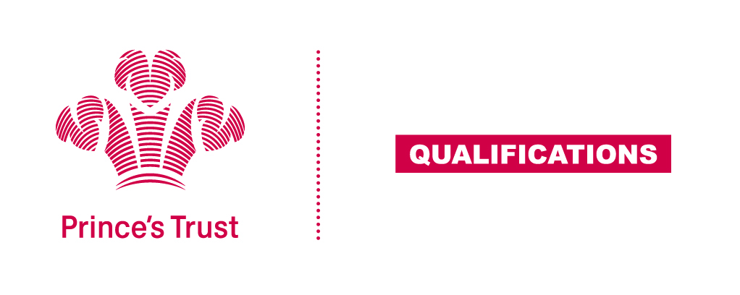
Tracking sheet – Preparing for a Healthy Lifestyle
The aim of this unit is to introduce learners to ways in which they can contribute to a healthy lifestyle and to encourage them to plan activities which will improve their own lifestyle such as a balanced diet e.g. food groups, risks of over/under eating; sufficient sleep; taking regular exercise; alcohol and drug awareness.
A key part to this unit at Levels 1 and 2 is the cooking of a healthy meal. The act of cooking supports the other aspects of the unit, and encourages learners to develop independent living skills. To be classed as cooking heat must be applied to food in some way; learners must therefore apply heat to at least one ingredient within the meal for it to be a suitable assessment activity.

Entry 3
Learner name Centre name
To do this you must | Page number | Assessment date
- Understand the factors that contribute to a healthy lifestyle
  - Give examples of things to include for a healthy lifestyle
  - Give examples of things to avoid for a healthy lifestyle
2. Be able to plan a healthy meal
  - Select a healthy meal
  - Identify the ingredients for this meal
  - Identify the steps involved in preparing this meal
3. Be able to make a healthy meal
  - Make the meal
  - Clean work areas and equipment used in making the meal
4. Be able to work towards a healthy lifestyle
  - Give examples of how to make own lifestyle more healthy

Assessor feedback
Declaration I confirm that the details above are correct, that the evidence submitted is the learner’s own work and that the learner meets all the requirements for the unit:
Learner Name Assessor Name

Learner Signature Assessor Signature

Date Date

