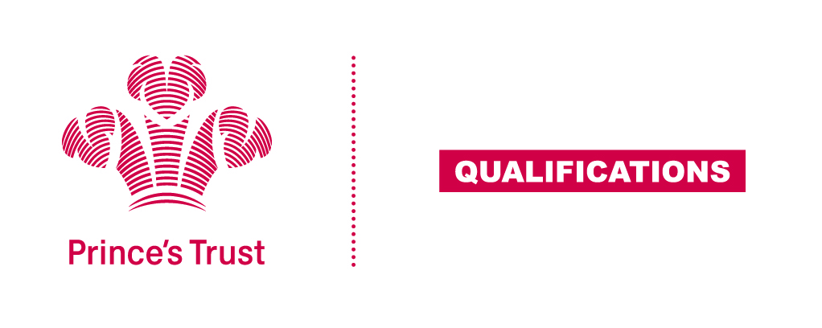
Tracking sheet – Digital Skills
The aim of this unit is to ensure learners are confident in using their digital skills to find, present and share information, are aware of the wider uses digital skills have within a workplace and understand some of the implications to using technology as a form of communication, both positive and negative.
Entry 3
Learner name Centre name
To do this you must | Page number | Assessment date
- Understand e-safety
1.1 Identify what is meant by "e-safety"
1.2 Identify positive and negative online behaviour
1.3 Identify the features which make a password secure
- Understand uses of digital skills and tools
2.1 Select tasks which require digital skills
2.2 Give examples of digital communication tools
- Be able to use digital tools to find and present information
3.1 Use the internet to find information on a subject
3.2 Present information using digital tools
- Be able to review own digital skills and identify areas for development
4.1 Identify own digital skills that need to be developed
Assessor feedback
Declaration I confirm that the details above are correct, that the evidence submitted is the learner’s own work and that the learner meets all the requirements for the unit:
Learner Name Assessor Name

Learner Signature Assessor Signature

Date Date

