INTERPERSONAL SKILLS
Advanced Workbook

NAME
SCHOOL

CONTENTS

Learning objectives 3
Body language 3
Body language and emotion 4
Communication 10
Managing behaviour 11
Types of behaviour 12
Time management 18
Stress Management 20
Physical Signs of Stress 20
Emotional Signs of Stress 21
Reflection 22

LEARNING OBJECTIVES

- To develop an understanding of interpersonal and self-management skills and be able to recognise these skills in ourselves and others.
- To consider the body language used by ourselves and others, time management skills and passive, assertive and aggressive behaviour and how to recognise and manage stress.

BODY LANGUAGE

STARTER ACTIVITY

Watch a clip on Youtube of a TV show or film you haven’t seen before with the sound turned off.
TV show or film name

What does the characters’ body language look like?

What do you think happened in the clip?

Now watch the clip again with the sound turned on – was your guess right?
Looking at someone’s body language often tells us how they’re feeling and is a way of communicating without using words. We all need to think about how we use body language and our actions to communicate with others.

Define non-verbal communication

BODY LANGUAGE AND EMOTION

ACTIVITY

Use the next four pages to draw a stick person that expresses the emotion at the top of the page. You can also find pictures and paste them onto the page.
Think about how their body language shows how they’re feeling and annotate each part.
What do their faces look like? How might they position and move their body parts?

HAPPY

UPSET

ANGRY

BORED

COMMUNICATION

TASK

When you’re having a conversation with someone, it is important to show them that you’re listening. ‘Active listening’ is when you show the person speaking that you are paying attention and taking in the information they are telling you.
Look up ‘active listening’ on the internet and describe what actions you can take to ensure you are concentrating on the other person talking and show them that you are listening.
1.
2.

3.

Explain why listening skills are important

When we talk to others we communicate through our words, body language and by actively listening. Have a conversation with a friend or family member and describe what techniques you used to effectively communicate talk with them.
Examples: eye contact, nodding head
1.
2.

3.

If you had that conversation with a family member how might you communicate differently with a friend? If you spoke to a friend, how might you instead speak to a stranger?

MANAGING BEHAVIOUR

Body language often tells us how someone is feeling, and it is important to think about how we want to conduct ourselves, especially towards others.
We can sometimes misunderstand body language because we do not understand the background of why someone acts the way they do. Think about the following example.

In Thailand, the head is seen as the most sacred part of the body – so it is extremely rude to touch anyone’s head.
Someone chooses to ruffle a Thai person’s hair.
What could the intention have been of ruffling hair?

How might a Thai person react?

Both people may have good intentions but a difference in background may lead to a miscommunication. It is important not to judge behaviour without understanding someone’s background.

TYPES OF BEHAVIOUR

ACTIVITY

On the following pages are lists that describe the characteristics and outcomes of three forms of behaviour – passive, aggressive, and assertive.
Cut out and stick them on the corresponding page. You can also copy and paste the lists if you’re on a desktop.
Write about an example of showing the behaviour.

Verbal characteristics
- Beating around the bush  - Quiet  - Hesitant, pausing a lot  - Long, rambling sentences  - Filler words (um, er, like)  - Making apologies – “I’m terribly sorry to bother you” | - Quick, perhaps rushed  - Loud  - Threatening  - Rude or sarcastic  - Firm  - Few hesitations | - Firm, relaxed voice  - Polite  - Seeks other opinions  - Steady, even pace  - Not loud or quiet  - Makes points clearly

Non-Verbal characteristics
- Intruding someone else’s personal space  - Fists clenched  - Staring  - Scowling  - Animated gestures  - Striding around | - Receptive  - Relaxed  - Good eye contact  - Welcoming  - Friendly  - Steady features | - Looking down / away  - Covering mouth with hand  - Poor posture  - Biting lip  - Fiddling with things / wringing hands  - Shaking / trembling

Thinking style
- “I won’t allow you to take advantage of you”  - “I won’t attack you for your ideas or opinions” | - “I don’t count”  - “My thoughts/feelings are less important than yours”  - “People will not like me” | - “I’ll get you before you get me”  - “I’m looking out for me”  - “I am going to win”

Positive outcomes
- Praised for being selfless  - Others will protect and look after you  - Conflict might be avoided in the short term | - Standing up for yourself is improves self esteem  - You can get what you want without upsetting people  - Positive relationships can be built | - You might get others to do what you want  - You can feel in control  - Release of tension

Negative outcomes
- Others can take advantage of you  - Can lose confidence  - Others might make unreasonable demands of you | - Behaviour can create enemies  - Relationships can be based on negative emotions  - You can often feel guilty after displaying this type of behaviour | - No outcome is guaranteed

Passive Behaviour
Where you sacrifice your own preferences and needs, so that you can help others to meet their preferences and needs.

Verbal characteristics | Non-verbal characteristics
Thinking styles | Positive Outcomes
Negative outcomes

An example of passive behaviour is

Aggressive Behaviour
Reactionary and impulsive behaviour that often results in breaking household rules or the law; aggressive behaviour is violent and unpredictable.

Verbal characteristics | Non-verbal characteristics
Thinking styles | Positive Outcomes
Negative outcomes

An example of aggressive behaviour is
Assertive Behaviour
Acting in your own best interests and standing up for yourself while still taking others’ views into consideration. Exercising your own rights without denying the rights of others.

Verbal characteristics | Non-verbal characteristics
Thinking styles | Positive Outcomes
Negative outcomes

An example of assertive behaviour is

TIME MANAGEMENT
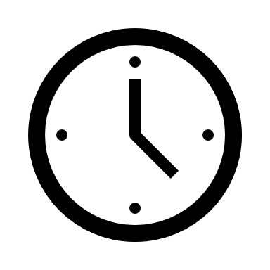

STARTER ACTIVITY

Find a stopwatch – you could use a clock or your phone. Start the stopwatch and without looking at it count to 60 seconds. Once you reach 60, check the stopwatch to see how close you were.
Do the same counting to 15 and 30 seconds.
How accurate was your counting? Was it easier timing a shorter period?

Time management is the ability to use one’s time effectively or productively.
Explain why time management is important

Describe a time when you managed time effectively

 | Mon | Tues | Wed | Thurs | Fri | Sat | Sun
08:00 - 10:00
10:00 – 12:00
12:00 – 14:00
14:00 – 16:00
16:00 – 18:00
18:00 – 20:00
20:00 – 22:00

STRESS MANAGEMENT

Has there been a point in the last month you have felt stressed? If you have, it’s perfectly normal and not something to worry about. We all feel stressed at points in our life. It is however important to recognise when you feel stressed and think about how to manage it so you’re not effected in everyday life.

PHYSICAL SIGNS OF STRESS

Annotate the stick person below with 5 physical manifestations / signs of stress. These are indicators we can see and feel. One example has been given for you.

Clenched fists

EMOTIONAL SIGNS OF STRESS

Now fill the boxes with 5 emotional or behavioural signs of stress. These are symptoms we can’t physically see but how stress can change our behaviours. One example has been given.
1. | A change in eating habits
2.

3.
4.

5.

Think of a time you were stressed and how you knew you felt that way. What did you do to help manage it?
Describe 5 techniques to manage stress. Think about people you could talk to and actions you could take:
1.
2.

3.
4.

5.

REFLECTION

So now that you have looked at body language, managing behaviour, time and stress you can think about your strengths and weaknesses in interpersonal and self-management skills.
Thinking about what has been covered in this booklet, describe 3 of your interpersonal and self-management strengths and weaknesses.

Strengths
1.
2.

3.

Weaknesses
1.
2.

3.

Describe 3 ways you would like to improve these weaknesses
1.
2.

3.

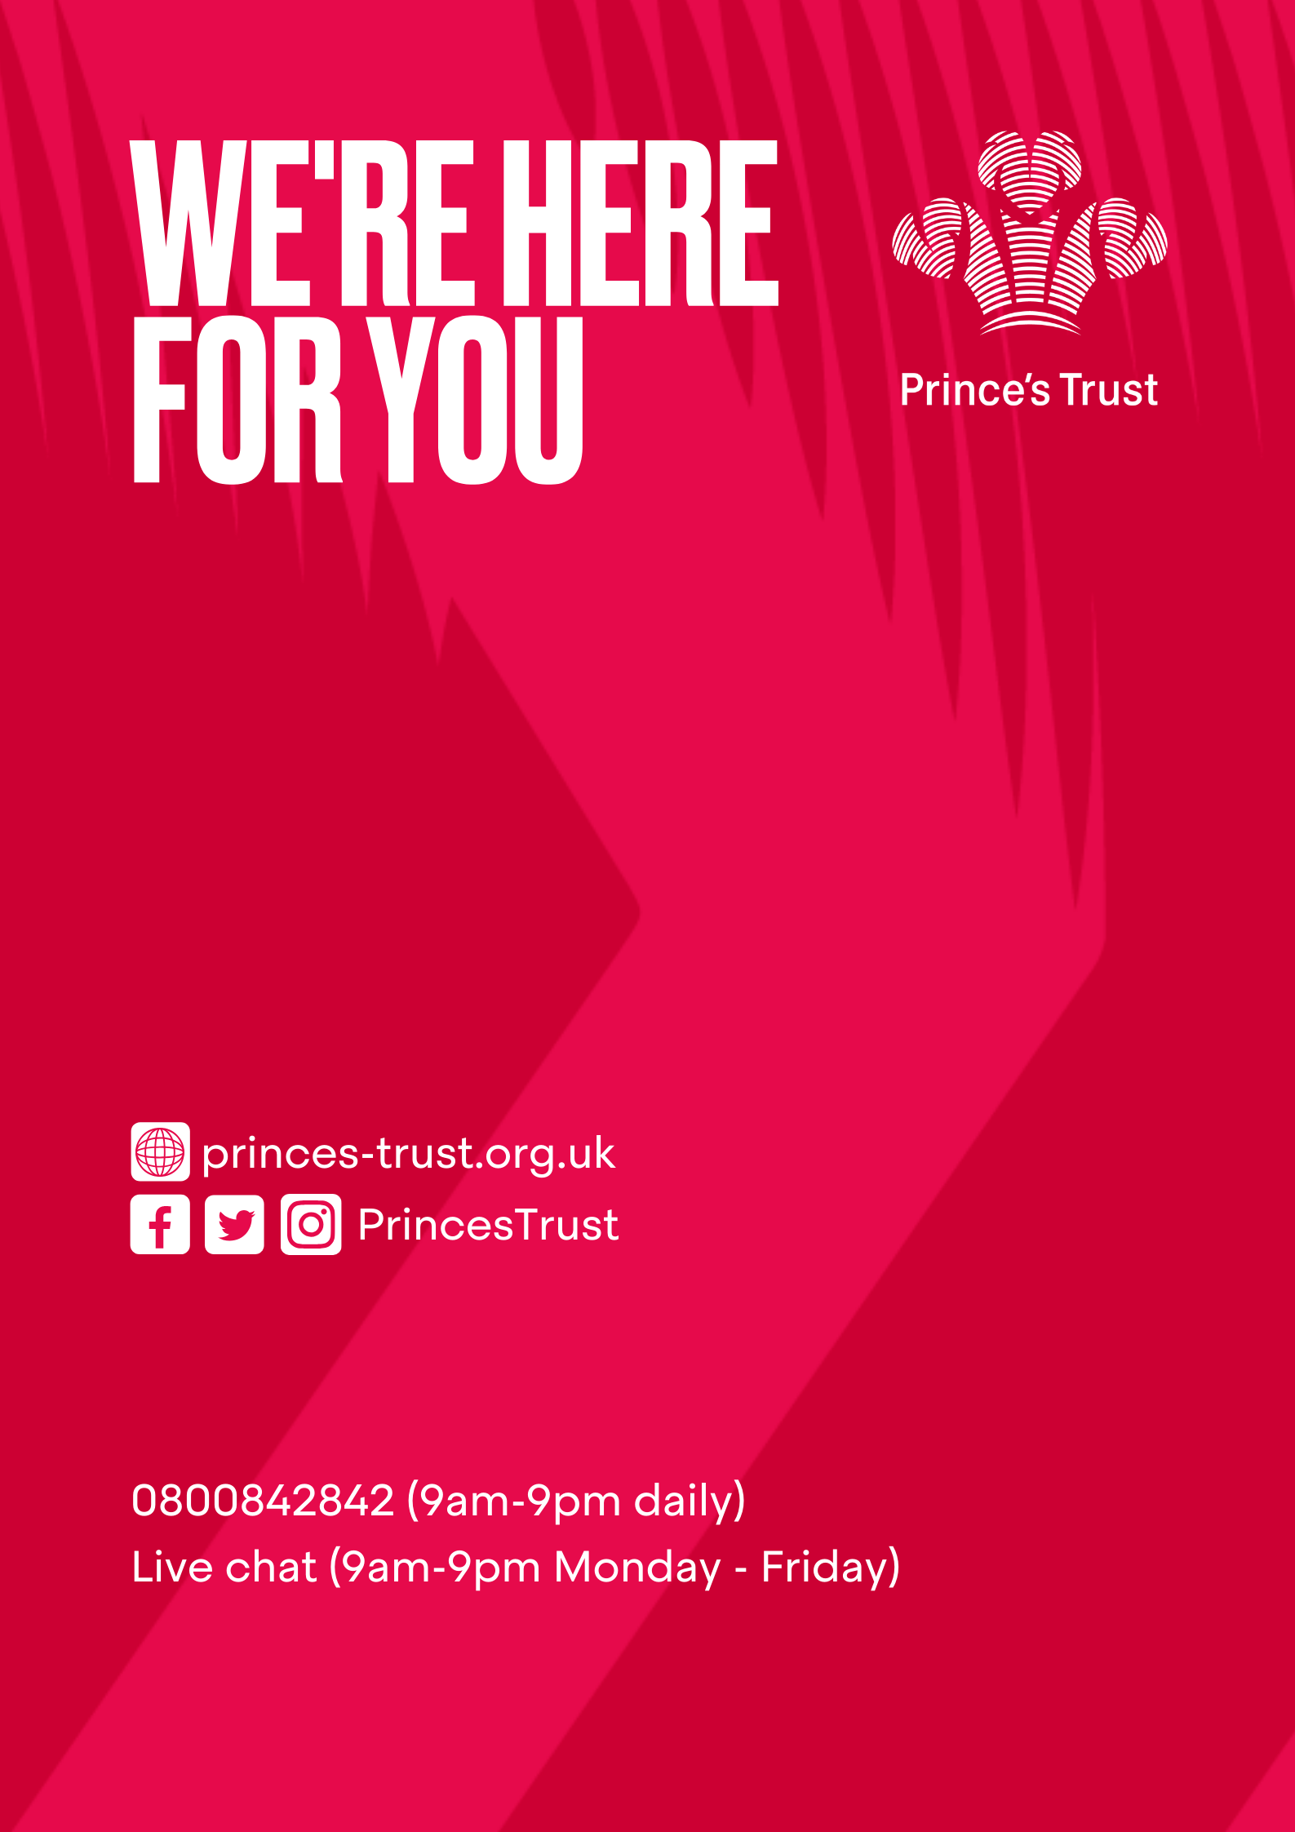

DSN 4055/2 © The Prince’s Trust 2020 – all rights reserved. The Prince’s Trust is a registered charity, incorporated by Royal Charter (RC000772). Principal office: The Prince’s Trust South London Centre, 8 Glade Path, London, SE1 8EG. Registered charity number in England and Wales (1079675) and Scotland (SC041198).

