DIGITAL SKILLS WORKBOOK
Intermediate Level Resource

NAME
SCHOOL

CONTENTS

Researching Topics 3
What is E-Safety? 5
Your Digital Footprint 9
Passwords 11
Present Information Using Digital Tools 13
Digital Skills in the Workplace 14
Finding, Sharing and Using Information Online 19
Putting it Together for the Furture 21
What Have You Achieved? 23

Researching Topics

ACTIVITY: GOOGLING
Spend 5-10 minutes using the website “A Google a Day” to practise your Googling Skills.

Some of the questions are quite tricky, but the game has hints to help you out! You can find “A Google A Day”:

http://www.agoogleaday.com/
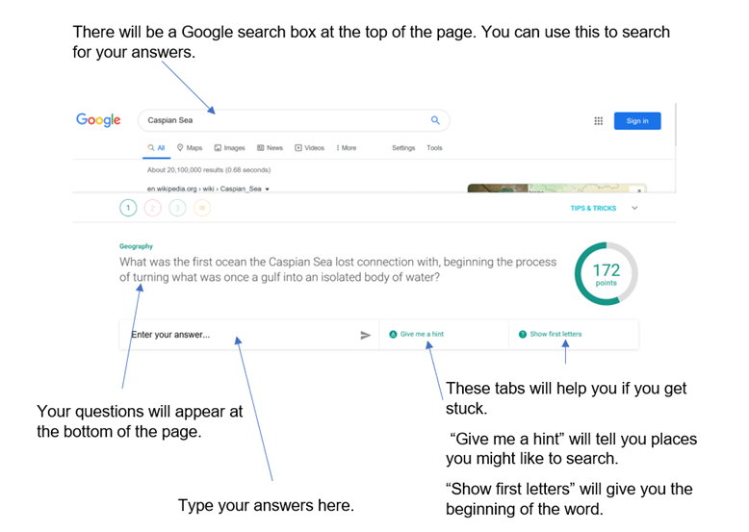

Once you have played a few rounds, choose one of the topics you Googled and use the Internet to search for 5 facts about it.
My topic was…

My top five facts are…

1.
2.
3.
4.
5.

Where might you share this information online?

Give 3 examples of places where people might share information online.

1.
2.
3.

What is E-Safety?

Now that you have some ideas about how to find and share information online, take a look at this short video about Digital Footprints. (https://www.youtube.com/watch?v=4P_gj3oRn8s)

1.1 ASSESSMENT TASK
State what is meant by e-safety
State: As if you are telling somebody else (remember: If you look this up online, you need to write your answer in your own words)

E-safety is...

Have a think (or talk to people in your home) about…

- Why is privacy important?
- Have you ever been in a situation where information that should have been private was shared?
- What information should stay private?
- And which information is it OK to share

1.2 ASSESSMENT TASK

Give examples of positive and negative online behaviours. (What should and shouldn’t you do online?)

Things you should do to stay safe online. 😊
1.
2.
3.
4.

Things you shouldn’t do online. ☹
1.
2.
3.
4.

Use the Internet (or ask others) to find out about different ways to keep your information safe online.

Can you give some examples?

1.3 ASSESSMENT TASK

Give examples of features that make a password secure.

Features that make a password secure are…

1.
2.
3.
4.
5.

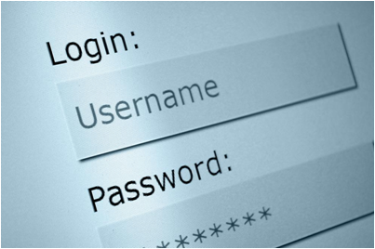

Your Digital Footprint

ACTIVITY

Think about what information about you might be online.

Are there any photos, blogs, comments, ‘likes’, tweets, tags, etc that you have made or that are about you?

Look yourself up on Google. Try searching your name, nicknames, full name and usernames.
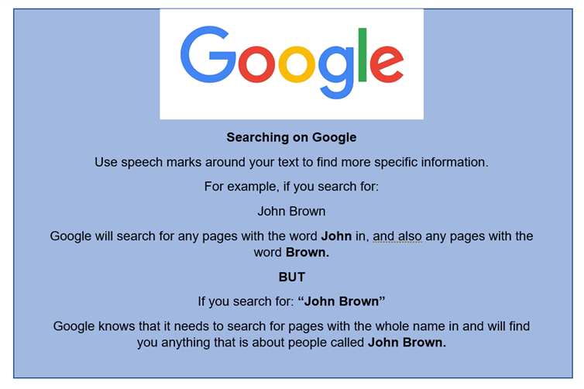

This is your digital footprint

Did anything surprising come up? What if you add the names of sites that you use, such as Instagram?

Note down some risks of all of this information being available online? For example, would you want future employers, or school staff to see information that might be public?

Risks might be…

Passwords

There are lots of ways to keep information safe.

A good way to keep information safe online is to use a strong password, and to remember to log out of any websites/social accounts/online banking after using them on a different device.
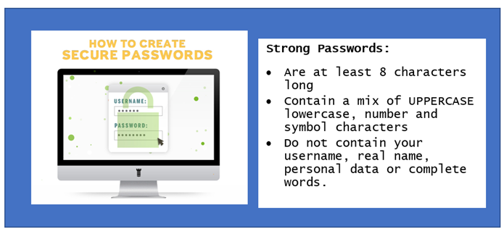

ACTIVITY: CREATING A PASSWORD

Write this activity on a separate piece of paper and then destroy it when you have a password you can remember.
REMEMBER: Do not keep passwords written down

You are now going to take a simple personal sentence and turn it into a strong password…

Step 1: Come up with a sentence that is personal to you, e.g. ‘Fish and chips are my favourite’

Step 2: Take away any spaces: Fishandchipsaremyfavourite

Step 3: Change some of the letters to CAPITALS: fiShandChiPsaremYFavourite

Step 4: Shorten some words and change spelling: fiShnChiPsrmYFave

Step 5: Add numbers and symbols: f1Sh&ChiPs_rmYF4ve

Present Information Using Digital Tools

3.2 ASSESSMENT TASK

Create a poster to give other young people advice on how to stay safe online. Use Paint, Microsoft Word, Publisher or any other digital design software you have access to.

Make sure you use pictures, colours, and different fonts to make your poster look exciting, so that it will grab people’s attention.

By making this poster, you are encouraging e-safety. If you follow these tips and do not take part in cyber bullying then you are being a good “Digital Citizen”.

Make sure that you save your poster and remember to hand it in, along with this workbook! If you don’t have access to design software at home, draw a design on paper and you can turn this into a digital poster when you can get to a suitable computer.

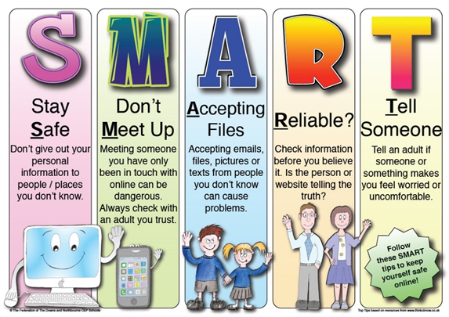

Digital Skills in the Workplace

Now that you know how to create a clean and safe online presence by protecting your information, which digital skills do you think might be important in the workplace?

2.1 ASSESSMENT TASK

Give examples of tasks that require digital skills. Think about jobs that people might need to do in the workplace using IT. E.g. Sending emails
Create a spider diagram or a list (below) to show your ideas.

3.1 ASSESSMENT TASK

Use the Internet to find information on a subject from different sources.

Choose one of the careers below, or a career of your choice:
- Office/Shop Worker (Digital Marketing Officer, Store Manager, Customer Service Officer, Sales Executive, Charity Programmes Manager, etc.)
- Architect
- Graphic Designer
- Crime Laboratory Analyst
- Legoland or Fashion Designer
- Digital Engineer
- Zookeeper
- Midwife or Nurse

Use the Internet to find out about the sort of jobs they do every day, which use digital/computer skills. Don’t forget that these might include tasks they do on the phone or using special digital equipment.

Use 3 different websites to find information. Print or save the information that you find. This could be screenshots of the pages.

Make sure you hand your research in along with this booklet. Don’t forget to make a note of which websites you used.

The career I researched was…

Tasks that might be involved are…

6.3 ASSESSMENT TASK

Present information using different digital tools.

If you need a refresher on your PowerPoint skills, or if you aren’t very confident, this video might be explains it very clearly. (https://www.youtube.com/watch?v=u7Tku3_RGPs) (or search YouTube for Microsoft PowerPoint Tutorial – Beginners Level 1)

Create a PowerPoint presentation about your chosen career:

This should have a title page and pages giving:
1. One sentence overview of the career
2. Examples of tasks using digital skills in this workplace
3. Examples of computer programs that could be used to help
4. Examples of typical digital skills for specific career (the things that someone might need to be good at to succeed in this job).
5. A photo of something related to the job

Save or print your presentation and don’t forget to hand it in with this booklet! If you can, share your presentation with people at home. A photograph of you doing this would be great to include!

Websites I used for research…
Website address | What I found out

If you would like to know more about digital skills for work, the following article is interesting and has links to other websites where you can find out about courses and organisations that help young people to develop their digital skills. You can read the article here:
https://www.theguardian.com/careers/ young-people-need-hone-digital-skills-futureproof-careers
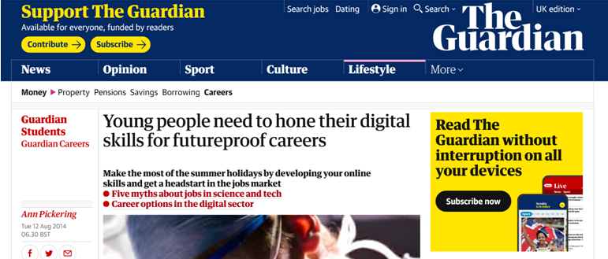

Finding, Sharing and Using Information Online

ACTIVITY: FANTASY HOLIDAY

We all love to dream about our favourite places or holidays that we would love to take.

- Think of a place that you’d love to visit.
- Create a spider diagram or mood board of images of that place (This could be done using travel websites, Instagram or Pinterest).
- Paste your favourite pictures into a document - or you might like to use brochures or magazines you have at home to make a paper-based mood board.

There lots of things to think about when planning a trip. We need to know about transport, accommodation, and activities, as well as clothing, dangerous places, or injections that we need to keep us safe.

Think about places you might contact for help or advice when planning your trip. For example, travel agents or tourist information agencies.

2.2 ASSESSMENT TASK

Consider the different digital communication tools you could use to get in touch with travel agents/tourist information agencies etc.

State the advantage(s) and disadvantage(s) of each type of digital communication. Use the table below to record your ideas.

Digital Communication Tool | Advantages | Disadvantages

Putting it Together for the Future

Now you have a good understanding of e-safety, digital skills for business and how to find, store and present information, it’s time to think about your own skills and how they might be developed.

ACTIVITY: FUTURE LEARNING

Have a look at the following websites to find out which opportunities they offer for further learning.

O2 Think Big

https://gothinkbig.co.uk/

Fluency

https://www.afternic.com/forsale/fluency.io?utm_ source=TDFS_DASLNC&utm_medium=DASLNC&utm_ campaign=TDFS_DASLNC&traffic_type=TDFS_DASLNC&traffic_ id=daslnc&

Future Learn

https://www.futurelearn.com/

Coder Dojo

https://coderdojo.com/

Do any of the opportunities appeal? If so, which ones?

What Have You Achieved?

ASSESSMEMT TASK 4.1

Give examples of own digital skills that need to be developed.

What are you most confident about when working on the computer and/or tablet? Give at least 3 examples. If you can give some more description, then that’s even better!

ASSESSMEMT TASK 4.2

Identify digital skills you can improve on.

Now have a think about things that you need to develop. Which digital skills do you need to work on? And how could you get better at them?

Digital skills I need to work on | What I could improve

Now that you’ve had time to reflect, perhaps you could try one of the programmes we talked about earlier? Or maybe you can find some free online courses to help you to practise your digital skills even more!

You have completed the Digital Skills workbook. Don’t forget to keep hold of the workbook so that you can take it to school and show it to your teacher!

