DIGITAL SKILLS WORKBOOK
Resources for Beginners
NAME
SCHOOL

CONTENTS

Welcome! 3
Understanding E-Saftey 4
Online Behaviour 8
Passwords 11
Use of Digital Skills 13
Digital Communication 16
Finding and Communicating Information 19
Developing Your Own Digital Skills 22

Welcome!
In this unit, you’ll be learning all about digital skills, including how to stay safe online, how to best use the internet for research and how to use technology to present information.

What are digital skills?
First up, let’s see what you think Digital Skills is all about.

TASK:

Write down or type as many words as you can that are connected to digital skills. We’ve included some examples to help get you started!

Computers
Communication

1. Understanding E-Safety

E-Safety is more important than ever. But what is it?

TASK:

Watch the following video:
https://www.youtube.com/watch?v=HAY8uDBCd3k

If the link is working, you can also search for ‘What is E-Safety?’ on YouTube. It is the first result.

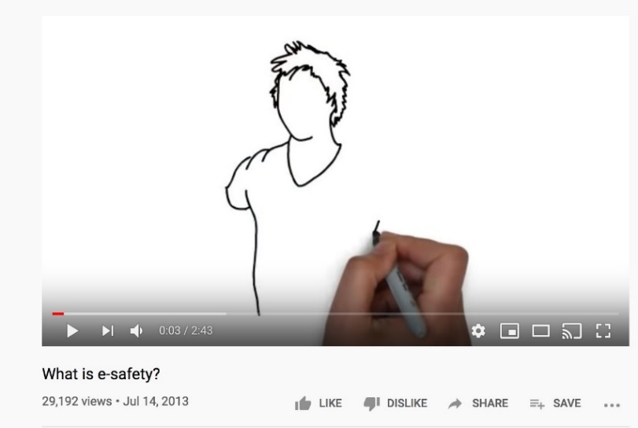

What are the four questions asked in the video?

1.
2.
3.
4.

How can these questions help you to stay safe online?

I think these questions can help you to stay safe online because…

1.1 What is meant by E-Safety?

TASK:

Use the tick boxes to choose the correct definitions of e-safety. There are four correct definitions for you to find.

E-Safety is about playing Fortnite with my friends

E-Safety means always having strong passwords for your online accounts

E-Safety is about not sharing personal details online

E-Safety is about not talking to strangers on the internet

E-Safety is when you Google a question to find out the answer

E-Safety is about staying safe when online

E-Safety is about not spilling water on my computer

2. Online Behaviour
Behaving responsibly, kindly and positively is very important in everyday life. That includes when you are online too.

TASK:

Think about different types of behaviour when you are in school.
- What does it look like when you are behaving well and positively?
- What about when someone is behaving negatively?
Can you name 3 examples of positive & negative behaviour at school?
Positive Behaviour
1.
2.
3.

Negative Behaviour
1.
2.
3.

TASK:

Do you think any of the positive and negative examples of behaviour can happen online too? Discuss this with at least one other person at home and explain your answer in the box below.

2.1. Identifying positive and negative online behaviour

TASK:

Kamal and Alisha are online.
Kamal is behaving positively but Alisha is behaving negatively. Use the tick boxes to match up the sentences with each person.

Kamal
Alisha

Sentence | Kamal or Alisha?
Some celebrities really annoy me. I love writing mean comment about them on Instagram. | TICK  BOX | TICK  BOX
I often go online to keep up to date with current affairs. | TICK  BOX | TICK  BOX
A boy at my school fell over today. I took a video of it. I’ll post it on all my WhatsApp group chats! | TICK  BOX | TICK  BOX
Wikipedia is great for my homework. I just copy and paste from there without reading it. | TICK  BOX | TICK  BOX
If I’m doing something interesting, I like to post it on my Instagram story. | TICK  BOX | TICK  BOX
I like chatting with my friends online to see how they are. | TICK  BOX | TICK  BOX

3. Passwords

A good way to keep information safe online is to use a strong password. You should also remember to log out of any websites/social accounts/online banking after using them on a different device.

Password Top Tips:
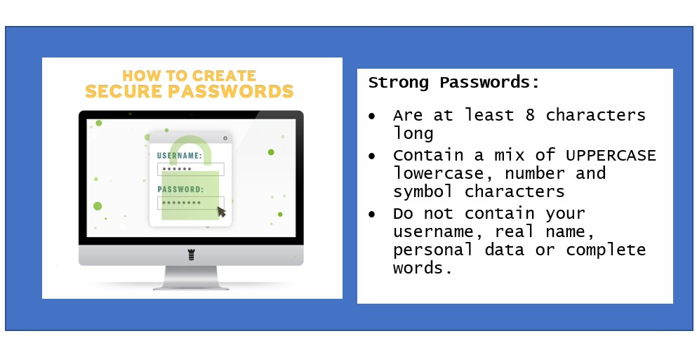

TASK:

Have a look at the passwords below. Which one do you think is the strongest? Which one is the least secure?

The strongest password is…

Fishandchips
FishandChips
F!sh&Ch!p525
FishandChips25

Now write down three things the password contains that makes it strong
1.
2.
3.

TASK:

Design a poster that encourages young people to use the internet safely.
If you have access to a computer, you can make your poster on that, or if you would prefer you can use a piece of paper.
You can draw pictures on your poster, or you can find pictures online.
However, you must write using your own words!
Your poster should include the following information:
    - What E-Safety is
    - Why E-Safety is important
    - Two examples of positive online behaviour
    - Two examples of negative online behaviour
    - Advice on how to make a strong password

4. Use of Digital Skills

We use digital skills for many different tasks every day. Have you done anything this week that used digital skills? Has anybody at home?

TASK:
Ask someone at home how they have used digital skills this week and write or type their answers below:
I have asked:

They have used digital skills this week by:

4.1 Task Which Require Digital Skills

TASK:
Below is a list of different tasks you might do every day. List the five tasks that involve digital skills in the box provided on the next page.
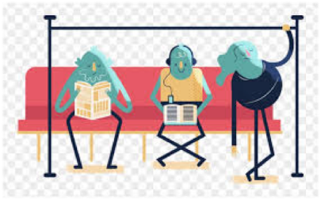

Producing music
Playing basketball
Travelling on the tube
Sending emails
Looking something up on Google
Reading the newspaper
Finding a route on your phone
Making a vlog

Sending a photo to a friend on WhatsApp
Shopping for gifts
Making breakfast

The five tasks that involve digital skills are…
1.
2.
3.
4.
5.

5. Digital Communication

The way that we communicate with each other has changed so much over the last 20 years. But can you imagine how much it has changed over the last 20,000 years?!

TASK:
Watch the video below. Are there any forms of communication that you don’t recognise? If you can, search online what they are.

https://www.youtube.com/watch?v=0ay2Qy3wBe8

If the link isn’t working, you can search for ‘A Brief History of Communication’ on YouTube. It is the second result
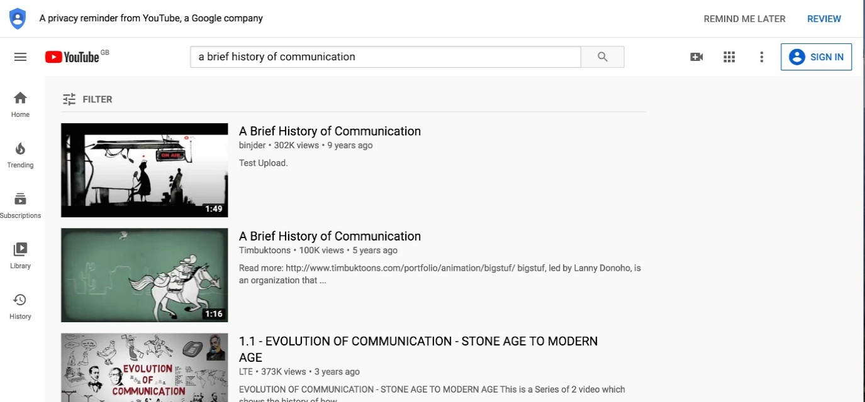

TASK:

From left to right, match up the forms of communication with the picture below. We have completed one for you to help get you started!
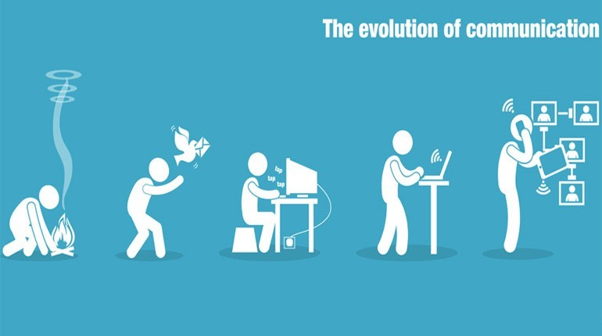

1.
2.
3.
4. | Instant messaging on a laptop
5.

5.1 Examples of Digital Communication Tools

These days, we use technology all the time to communicate with other people.

TASK:
Write or draw/insert a picture in each empty box of a method of using technology to communicate with people.
Make sure you label each picture.

Email

Communicating Using Technology

6. Finding and Presenting Information

In this section, you’ll be using the internet to research information on a topic and using a computer to present that information.

TASK:

Imagine that a friend wants to buy a new phone and has asked you for advice on which one to get. Research which phone you think your friend should buy and fill in the information below:

Make of phone
Model of phone
Dimensions of phone
Storage space
Information about camera
Price
Why it is a good phone
Any disadvantages

6.1 Present Information Using Digital Tools

Now you’ve done some brilliant research, it’s time to present it!

TASK:
Create a PowerPoint presentation showing all of the information about the phone that you have researched.
If you need a refresher on your PowerPoint skills, or if you aren’t very confident, this video explains it very clearly.
https://www.youtube.com/watch?v=u7Tku3_RGPs

If the link doesn’t work, you can search for ‘Microsoft PowerPoint Tutorial – Beginners Level 1’ on YouTube.

Your presentation must include:
- at least four different slides
- all of the information that you have written in the table
- at least two different pictures of the phone
CHALLENGE!

Can you also include some animations in your presentation?

7. Developing Your Own Digital Skills
Well done on making it this far in the course!

TASK:

Below you’ll find all of the topics that we’ve covered in this course. In the box by each topic, write a number between 1-5 depending on how confident you now feel with that topic.
- 5 means you really understand the topic
- 1 means you don’t feel confident at all with the topic
Understanding E-Safety

Behaving positively online

Making a strong and safe password

Using digital skills in everyday life

Using technology to communicate

Finding and presenting information online

Now write down at least one topic of Digital Skills that you would like to improve and why.
I would like to improve:

Because…

You have completed the Digital Skills workbook. Don’t forget to keep hold of the workbook so that you can take it to school and show it to your teacher!

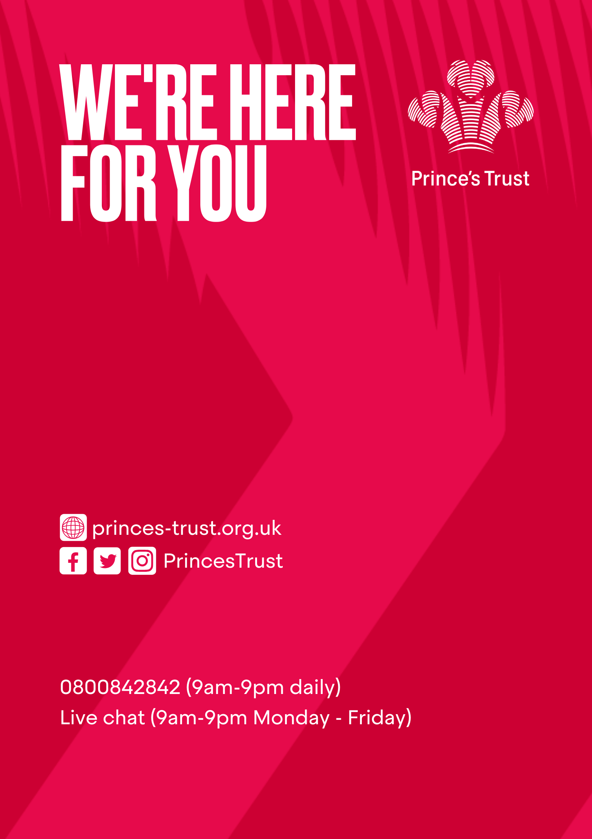

DSN 4055/2 © The Prince’s Trust 2020 – all rights reserved. The Prince’s Trust is a registered charity, incorporated by Royal Charter (RC000772). Principal office: The Prince’s Trust South London Centre, 8 Glade Path, London, SE1 8EG. Registered charity number in England and Wales (1079675) and Scotland (SC041198).

