CAREER PATHWAYS AND CV WRITING WORKSHOP

NAME
SCHOOL

CONTENTS
CAREER PATHWAYS AND CV WRITING WORKSHOP 3
AS YOU WORK THROUGH THIS BOOKLET, YOU WILL: 3
[20 MINS] 4
ACTIVITY 1: PROFESSIONAL CASE STUDY ON YOMI ADEGOKE 4
Can you identify 3 skills that are required in the job role of a journalist? 5
Can you identify what Yomi did to gain experience in journalism while at university? 6
In her year out, what were TWO positive actions Yomi took to develop her writing skills and experience? 6
In which ORDER did Yomi begin in her career as a Journalist? 7
Can you give TWO examples of skills or qualities that are important in the workplace and why? 8
Reflecting on Yomi’s journey overall and the steps she took to be where she is today, the challenges she has faced and the achievements she has had, what will you personally take away from her story? 8
[30 MINS] 9
ACTIVITY 2: CAREER PATHWAYS 9
Example: 9
Career Pathway 1: 11
Career Pathway 2: 12
[15 MINS] 14
ACTIVITY 3: SKILLS AND EXPERIENCE 14
MY CURRENT/PLANNED WORK EXPERIENCE 16
[30 MINS] 18
ACTIVITY 3: CREATING A CV… 18
Chosen Job Role: 18
WORD CLOUD: CV KEYWORDS 21

CAREER PATHWAYS AND CV WRITING WORKSHOP

Welcome, in this workbook we aim to give you a real insight into the world of work and inspire you with the pathway of Yomi Adegoke, an award-winning Journalist and Author!

AS YOU WORK THROUGH THIS BOOKLET,

YOU WILL:

- Produce a case study on Yomi Adegoke, to learn about her pathway into her career as a Journalist and Author

- Research into TWO career pathways you are interested in and find out what is expected from you and the job

- Reflect on your own skills, experience, and interests and how these can be applied to your chosen job role

- Create your very own CV

[20 MINS]

ACTIVITY 1: PROFESSIONAL CASE STUDY ON YOMI ADEGOKE

Name: Yomi Adegoke
Age: 28
From: Croydon, London
Profession: Journalist and Co-Author of ‘Slay in Your Lane: The British Black Girls Bible’
Listen to Yomi’s Story.

Having watched Yomi’s story, we are now going to create a case study on Yomi’s pathway into Journalism.
By researching into Journalism here you can find out lots more information on the job role which will help in answering some of the questions below.
This activity will give you the bigger picture of how Yomi went from school into her career, highlighting the challenges, opportunities and steps she takes to progress from school leaver to career breaker.

Can you identify 3 skills that are required in the job role of a journalist?

1
2
3

Having watched Yomi’s Story, can you list 3 skills you identified Yomi as having and explain why?
Example: Approachable, she has a positive tone of voice and confident body language

1
2
3

Which Degree did Yomi take at university?
(tick ONE correct answer)

English Literature | ☐
Sports Science | ☐
Law | ☐

What was the name of the university Yomi attended?
(tick ONE correct answer)

London South Bank University | ☐
Warwick University | ☐
Manchester University | ☐

Can you identify what Yomi did to gain experience in journalism while at university?

Yomi speaks honestly about her mental health and how she made the decision to take a year out of her Degree.

In her year out, what were TWO positive actions Yomi took to develop her writing skills and experience?

1
2

In which ORDER did Yomi begin in her career as a Journalist?
(Copy-Paste or Write in your answer)

VPoint News
Intern at The Telegraph
Co-wrote a book: Slay in Your Lane
Columnist at The Guardian
Online Producer at Channel 4 News

First
Second
Third
Forth
Fifth

In Yomi’s top tips for getting into journalism, she speaks about how important being professional and polite is in the workplace.

Can you give TWO examples of skills or qualities that are important in the workplace and why?
Example: being polite, because it is important to respect those around you to enable you to work well with others and build positive relationships

1
2

Reflecting on Yomi’s journey overall and the steps she took to be where she is today, the challenges she has faced and the achievements she has had, what will you personally take away from her story?

[30 MINS]

ACTIVITY 2: CAREER PATHWAYS

In this activity you will be researching into TWO potential career pathways you are interested in or would like to know more about.

Using the Youth Employment careers hub, which has lots of information on different industries and job roles, you can find all the information you need to complete this activity.

Pick TWO job roles using Youth Employment’s website and fill in the blank templates given below.

Here is an example of what information you need to find and fill in:

Example:

Industry: | Creative and Design
Weekly Salary: | £600
Hours/Week: | 40h
Job Title: | Graphic Designer
Yearly Salary: | £31,200
Hourly Pay: | £15

Entry Requirements/Qualifications:
- You don’t need any formal qualifications to become a graphic designer, but qualifications do help you grow your design skills:
  - BTEC Diploma – 4 GCSEs with a passing grade of 9-4
  - HNC/HND – 1 A-Level/BTEC Diploma in Art and Design
  - Degree – 4 GCSEs and 2 A-levels or equivalent
- A portfolio is a visual CV of work you have done, show your creativity, skill and style
- Get on an Apprenticeship, training and earning at the same time

Experience Needed:
- If you like making designs, consider researching stores online that can turn these into t-shirts, cards, magnets, anything else
- Draw, draw in different ways, link up with other artists on social to share creativity
- Using software like Adobe Illustrator/Photoshop and CorelDRAW
- Create a personal blog with a professional feel. This is a chance to show off your website design, you can host your portfolio on your blog, or any visual works in progress

Skills for this Role:
- Self-Belief
- Design skills and attention to detail
- Teamworking skills
- IT Skills

Career Pathway 1:

Industry:
Weekly Salary:
Hours/Week:
Job Title:
Yearly Salary:
Hourly Pay:

Entry Requirements/Qualifications:

Experience Needed:

Skills for this Role:

Career Pathway 2:

Industry:
Weekly Salary:
Hours/Week:
Job Title:
Yearly Salary:
Hourly Pay:

Entry Requirements/Qualifications:

Experience Needed:

Skills for this Role:

[15 MINS]

ACTIVITY 3: SKILLS AND EXPERIENCE
Now you have researched TWO potential job roles you are interested in; it is time to look at your own skills and experience.
In this activity we will be identifying the skills and experience you currently have and possible actions you can take in developing and building on these.
Using the diagram below, read carefully what each skill means.
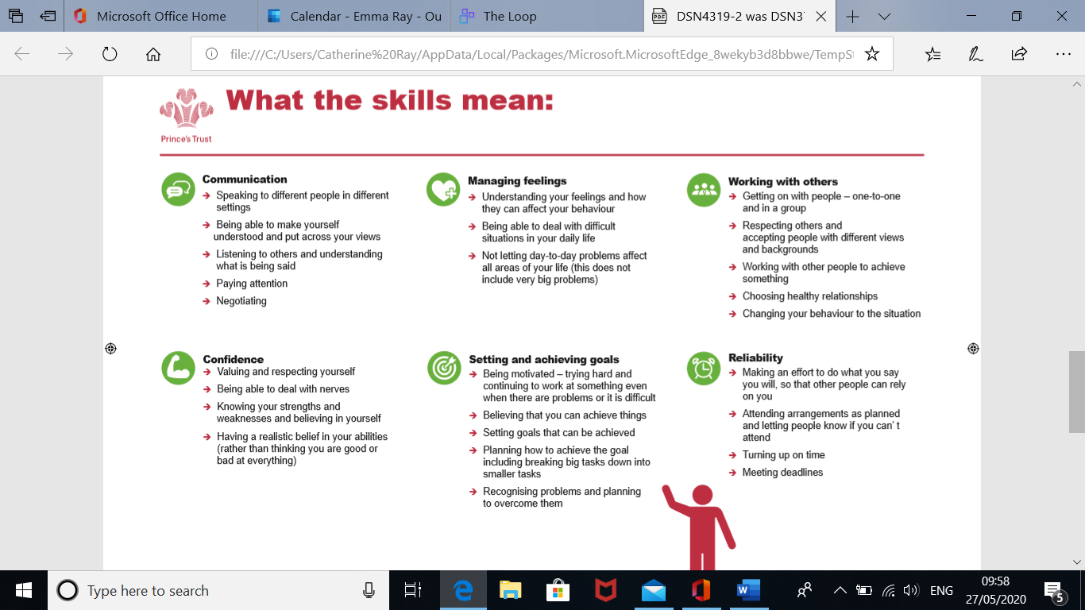

Next, rate how you feel about each of the 6 skills
(WRITE in the number) – be honest! The scale below explains what each number represents:

What the Numbers mean: 1 – 6
1 | 2 | 3 | 4 | 5 | 6
Find this skill difficult and struggle a lot | Difficult but looking to improve but don’t know how | Find it okay but need some support sometimes | Quite good at this but want to improve | I am good at this skill and rarely need support | I excel at this!

Communication
Teamwork
Setting and Achieving Goals
Confidence
Reliability
Managing Feelings

Having reflected on the 6 skills above, you should have a better picture of which skills you are strong in and those you will develop further.

For the next activity, use the boxes to write down your skills, experience, achievements, hobbies and interests. This will make it simple to complete your CV as you will have all the information you need noted, ready to place into your template.

Try to be as detailed as possible to make the next activity easier!

MY TOP 3 SKILLS

1
2
3

MY CURRENT/PLANNED WORK EXPERIENCE
Tip: think about the job roles you researched, what could you look to do to give you the experience you need…

MY PERSONAL ACHIEVEMENTS
Tip: have you gained any awards at school or in a sports team/youth club?

MY HOBBIES & INTERESTS/PASSIONS
Tip: have you gained any awards at school or in a sports team/youth club?

[30 MINS]

ACTIVITY 3: CREATING A CV…
Now you have investigated TWO potential career pathways, it’s time to create a CV that is suitable for one of these job roles. Choose ONE that you will now focus on.

Chosen Job Role:

A CV is a written overview of your skills, education, and work experience. They are used to show potential employers when you are looking for a job.

Although there is no official CV structure, certain key information should always be included.
Here a few essential things you should aim to cover in your CV:
- Your personal details (e.g. name, location, phone number)
- A Personal Statement (a brief personal summary of who you are and what you are looking for)
- Relevant key skills (communication, teamwork, computer skills, etc)
- Work experience (listed with the most recent coming first)
- Education and Qualifications (listed with the most recent coming first)
- Hobbies and Interests (if you think they might help you get the job)
- References (often available on request)

Using all the information you have put together in the previous task with your skills, experience and interests, fill in the CV template and add in any further information you may have missed out.

There are explanations and examples included in red to guide you. Remember, make sure you are relating back to your chosen job role, think about:
- What skills do I have that are relatable to this job role?

- What experience do I need to show I have for this industry?

- Which hobbies/interests do I enjoy that are relevant to this job role?

Top Tip: Use the Word Cloud below to include some important Keywords!

Forename Surname
Location: xxxxxxx
Contact Number: xxxxxxxxxx
Email: xxxxxxxxxxxxx
Professional profile
Provide a summary of your abilities including detail on the skills and knowledge you have to offer employers, including your educational achievements, grades, and projects. Expand on transferable workplace skills you have gained throughout your studies, such as communication, teamwork, organisation, planning, IT skills etc. Also, if you have any impressive extra-curricular activities, then it is worth touching upon them here and describing the type of work you are interested in.

Education and Qualifications
- School name – Dates attended (from – to)
  - Qualification – Grade
  - Qualification – Grade
  - Qualification – Grade

Achievements
- Positions of responsibility in school  - Extracurricular activities | - Personal projects  - Clubs and sports teams

Awards and Recognition
- DoE – 20/05/2019
- Award and awarding body – Date achieved

Interests & Hobbies
- List any interests that could be relevant to the roles you are applying for, or could generally be deemed as impressive, such as competing in contests, fundraising, volunteering, creative arts or playing sports.

WORD CLOUD: CV KEYWORDS

When writing a CV, it is important to include keywords that relate your skills and experience to the job role for which you are applying to.

Keywords are simply a way for employers to quickly identify whether you have the right skills or attributes for the job.

For Example: If you were applying for a job as a customer service assistant in a shop which requires you to serve customers and work in a team. Keywords employers would like to see in your CV would be Communication and Teamwork, sharing examples of how you have used these skills.

Example: Communication - I was elected to be a prefect at school which gave me responsibility of sharing important messages with teachers and pupils, it was important I had good communication to make sure the right information was shared clearly and I could confidently talk to many people.

Below is a word cloud of potential keywords you may find appropriate to include in your CV for the job role you are focusing on:

Reliable
Strong Attention to Detail
Communication
Organisation
Time Management
Digitally literate
Self-Motivated
Multi-tasker
Teamwork
Confident
Approachable
Independent
Public Speaking
Strong Work Ethic
Adaptable
Trustworthy
Responsible
Innovative
Confident
Pro-active
Positive
Honest
Creative
Dependable
Energetic
Personable
Flexible
Driven
Imaginative
Team Player

NEXT STEPS!

Congratulations! You have now completed:

- A case study on the professional life of Yomi Adegoke

- Researched two potential career pathways you are interested in pursuing

- Identified your key skills, experiences, achievements, and interests related to your professional development

- Created a CV!

So, what now?
Your professional development will be continuously growing, you will adapt your CV many times as you move on from secondary school, further education, employment, and training. Because of this, here are some helpful tips to keep in mind:
- Whenever you take part in a team activity, complete a project or volunteer, make sure you document this, either on your phone or update your CV as you go, whatever works best for you. All the skills you develop from these opportunities will add up to lots of experience!

- If you are not sure on what you want to do after school, do not worry. Everyone develops their ideas and pathways at different times. Focus on what you enjoy and be inquisitive, investigate how you can make what you enjoy into a career?

- Keep in mind Yomi’s story, her pathway took many different routes before she became a journalist. Every challenge she faced gave her the opportunity to grow her skills and learn from these experiences – remember, every positive and negative experience is an opportunity to learn!

Continue your Journey:
The Mix - The Mix is the UK’s leading support service for young people. We are here to help you take on any challenge you are facing. Talk to us via our online community, on social, through our free or our confidential helpline.
Mind - Leading charity in Mental Health support, Mind have resources and support to help you manage your health and wellbeing.
Youth Employment UK - Experts on youth employment and unemployment, they are ideally placed to understand the complex landscape facing young people.
Prince’s Trust Support Hub - Support on gaining more confidence, learning new skills and getting into employment, talk to one of our friendly youth workers to find more ways we can support you.

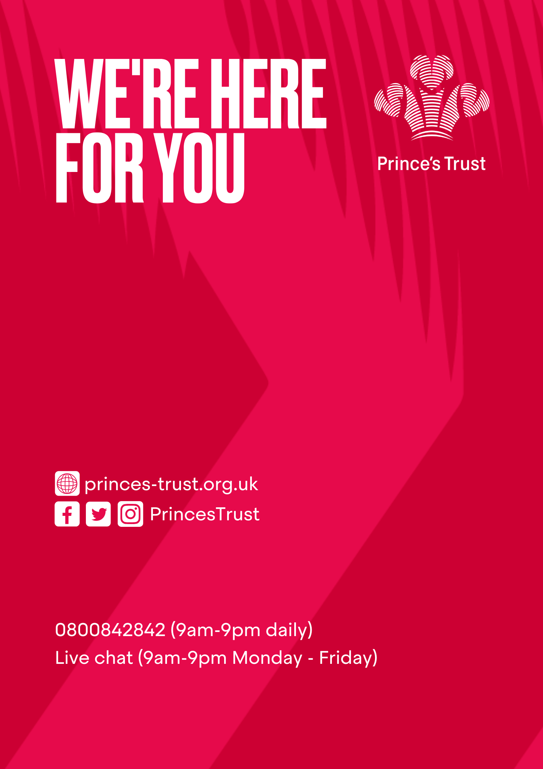

DSN 4055/2 © The Prince’s Trust 2020 – all rights reserved. The Prince’s Trust is a registered charity, incorporated by Royal Charter (RC000772). Principal office: The Prince’s Trust South London Centre, 8 Glade Path, London, SE1 8EG. Registered charity number in England and Wales (1079675) and Scotland (SC041198).

