Communication - Body Language
Look for pictures online, in magazines or newspapers of people demonstrating good and bad body language.
Write in examples of positive and negative body language.
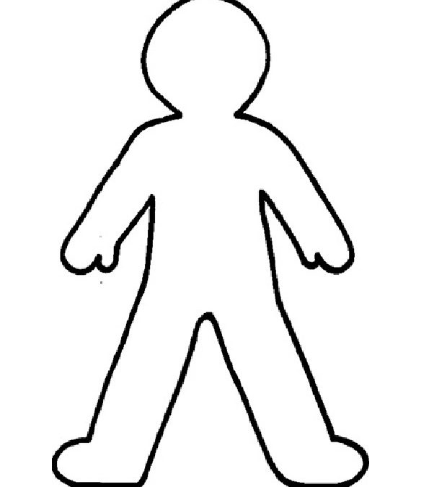

Positive Body Language | Negative Body Language

